Peru:
An Overview of Open Educational Resources (OER) Projects, Policies, and Research

Mariana Eguren
Instituto de Estudios Peruanos – IEP

Peru has a population of 29.9 million. Its GDP amounts to US$203.8 billion and the GNI per capita is US$6,060, which has recently positioned the country among the upper middle income countries. Pertaining to digital development, Peru shows some interesting advances in Internet penetration, however, broadband penetration and Internet speed are still challenges to be addressed. The same can be said about the regulatory framework for the telecommunications sector and the use of information and communication technologies (ICTs).

This paper begins by providing information regarding the nation’s infrastructural and technical issues concerning digital development. Next, we present relevant data in regard to Peru’s higher education system. In a third section, we analyze the country’s regulatory and policy context with regards to information and communication technology (ICT) and education. The following part of this document presents OER initiatives in which Peru is participating. No academic articles regarding OER in Peru were found for this review.

1. Infrastructure and technical readiness for OER adoption

Peru has 34.1% of Internet penetration, which is one of the lowest in the South American region, only above Ecuador, Paraguay, and Bolivia.

Chart 1: Internet Penetration (%)
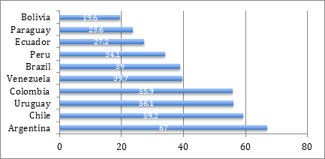
Source: www.internetworldstats.com (data updated for 2011)

According to Bibolini (2013), the level of “penetration reflects the country’s poverty map. Fixed-line and mobile subscribers are highly concentrated in urban areas – particularly the capital city. Besides poverty, another challenge for Peru is the rugged topography of the Andean mountains and Amazon jungles.”

Regarding broadband penetration, it amounts to 7.2% for mobile penetration and 3.1 for fixed penetration, which, compared to the rest of South American countries, is only above Ecuador, Bolivia, and Paraguay.

Chart 2: Broadband Internet Penetration (%)
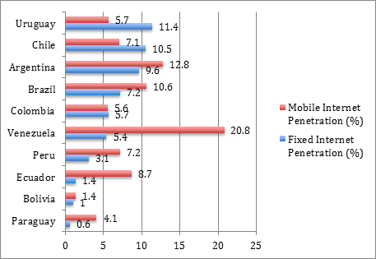
Source: ITU 2011, García Zaballos & López-Rivas 2012

Broadband speed in Peru is slow, at 1.7 Mbps, in spite of being one of the most expensive services in South America at USD PP 105 per Mbps.

Chart 3: Broadband Speed (Mbps)
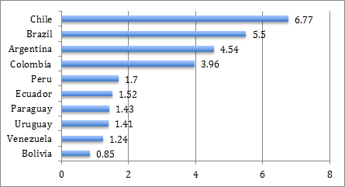
Source: Galperin and Ruzzier 2011, cited in García Zaballos & López-Rivas 2012

Chart 4: Average Price per Mbps (USD PPP per Mbps)
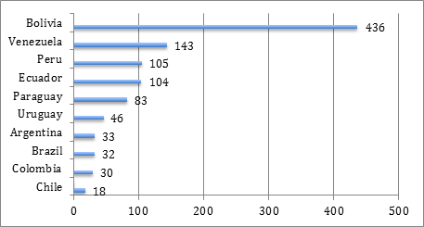
Source: Galperin and Ruzzier 2011, cited in García Zaballos & López-Rivas 2012

In conclusion, at the present time, Peru does not offer the best technical conditions for OER development. It is imperative to improve Internet and broadband Internet penetration, speed and cost.

2. Educational framework. Higher Education Institutions (HEIs) in Peru

Peru is one of the South American countries where the expansion of HEIs has been more extreme. At the present, there are 101 universities in Peru; this fact positions the country only behind Brazil, which has 186 universities (Cuenca 2013a). Such expansion has occurred mainly through the creation of private universities in different cities: 61% of Peruvian universities are private (Cuenca 2013a).

In terms of coverage, Peru has one of the lowest rates along Brazil (34%). 61% of said coverage corresponds to private universities (Cuenca 2013a). Castro, Yamada & Arias (2011) add to the latter the fact that “Access to higher education in Peru is remarkably regressive. According to the latest national household survey (ENAHO 2010), in the bottom 20% of the income distribution, only 37% of individuals with completed secondary were able to enroll in some type of higher education. In contrast, nearly 80% of youngsters in the richest 20% had access to this educational level” (p. 3).

The Peruvian higher education system has been historically a segmented one. In fact, according to Cuenca cited by Rocha y Welter (2013), it is an imperative challenge to “address the fact that enrolment is segmented by poverty levels and ethnic indicators. [In the Peruvian higher education system], each one gets the education they can afford” (p. 26).

Castro, Yamada & Arias (2011) consider that the situation is worsened by the fact that “Unlike other countries of the region (like Colombia or Chile) and almost every developed country, Peru lacks a publicly subsidized credit scheme for higher education investments” (p. 9).

The impact that OER adoption to improve access and quality of tertiary education could have in this context is extraordinary.

3. Legal and policy aspects

The main regulatory authority in the country is the Ministry of Transport, Communications, Housing and Construction (MTC). Under its leadership, experts developed in 2011 the Information Society Development Plan for Peru, also known as Agenda Digital 2.0 (Digital Agenda 2.0). Among its 8 objectives, the agenda formulates the following: to promote the inclusive and participative access of urban and rural populations in the information society, to support the development of digital competencies and abilities, and to encourage research and production regarding ICTs. To achieve them, the Agenda proposes a comprehensive set of strategies regarding fiber optic network, connectivity, and educational initiatives. Unfortunately, there are not specific goals or indicators set in the Agenda.

With regards to copyright and intellectual property, Peru follows the national Copyright Law (Legislative Decree No. 822). However, there is also a national chapter of Creative Commons led by the affiliate institution CPSR-Perú, an organization devoted to the analysis of the intersections among law, technology, and society.

In regard to initiatives developed by the educational sector, it is important to mention the One Laptop Per Child – OLPC program, to improve access and use of ICTs in rural schools.

4. OER Programs and Initiatives
We were not able to find many OER initiatives in Peru, besides the regional programs. It seems clear that the country could benefit from more initiatives in this regard.

· PerúEduca
www.perueduca.pe
PerúEduca is the official educational portal of the country. It is part of Red Latinoamericana de Portales Educativos – RELPE (Latin American Network of Educational Portals), along with other Latin American countries’ portals. In contrast to the rest of RELPE portals reviewed for this research, users have to register to use the resources offered by PerúEduca. This may result inconvenient, in case resources are segmented according to the type of user (teachers, students, families, directors, and allies).

· Educared
http://www.educared.org/global/educared/;jsessionid=2925E522E6332C6260AF4CCE63EFD716
Educared is an initiative of the Telefónica Foundation in Argentina, Brazil, Chile, Colombia, Venezuela, Spain, Mexico, and Peru to improve the quality of education. Educared is not an OER initiative per se, but the program focuses its actions in promoting the use of ICTs for education, and offers free online resources specially developed by the program.

· Proyecto LATin – Iniciativa Latinoamericana de Libros de Texto Abiertos (LATin Project – Latin American Initiative for Open Textbooks)
www.latinproject.org
Peru participates in this initiative to create collaborative open textbooks through Universidad Católica San Pablo (UCSP).

· COLABORA – Comunidad Latinoamericana de Bibliotecas y Repositorios Digitales
(COLABORA – Latin American Community of Libraries and Digital Repositories)
http://www.saber.ula.ve/colabora/
Peru participates in this digital libraries and repositories project through Universidad Peruana de Ciencias Aplicadas – UPC.

· OportUnidad Project
www.oportunidadproject.eu
This promising international OER initiative has a Peruvian affiliate in the Universidad Inca Garcilaso de la Vega.

· OCW-Universia
http://ocw.universia.net/es/
Peru participates in OCW-Universia through Universidad Nacional San Agustín de Arequipa, Universidad Nacional de Ingeniería, and Universidad de Ciencias Aplicadas.

5. Research / Researchers

No articles on open educational resources were available at the SciELO, RedALyC, and LACLO repositories.

References

Bibolini, L. (2013): Peru - Telecoms, Mobile, Broadband and Forecasts. In: https://www.budde.com.au/Research/Peru-Telecoms-Mobile-Broadband-and-Forecasts.html. Retrieved on Nov. 26, 2013

Castro, J., G. Yamada & O. Arias (2011). Higher Education Decisions in Peru: On the Role of Financial Constraints, Skills, and Family Background. Lima: Centro de Investigación de la Universidad del Pacífico.
http://srvnetappseg.up.edu.pe/siswebciup/Files/DD1114%20-%20Castro_Yamada_Arias.pdf

Comisión Multisectorial para el seguimiento y evaluación del plan de desarrollo de la sociedad de la información en el Perú (2011). Plan de Desarrollo de la Sociedad de la Información en el Perú. La Agenda Digital 2.0. Lima: Presidencia del Consejo de Ministros
http://www.codesi.gob.pe/docs/AgendaDigital20_28julio_2011.pdf

Cuenca, R. (2013a). Higher Education for Latin America: Two Challenges in a Field of Opportunities. In Stead, V. Ed. International Perspectives on Higher Education Admission Policy. New York, NY: Peter Lang. (Forthcoming).

Cuenca, R. (2013b). E-learning, educación superior y competitividad en Iberoamérica. (Manuscript).

García Zaballos, A. & López-Rivas. (2012, November). Socioeconomic Impact of Broadband in Latin American and Caribbean Countries. Inter American Development Bank. (IDB Technical Note; 471). http://www.iadb.org/intal/intalcdi/PE/2013/11427.pdf

Rocha, F. & Z. Welter (2013). Reformas a la Educación Superior en América Latina: Ecuador, Chile, México, Perú y Colombia. Memorias del encuentro. Bogotá, 23 de octubre de 2013.
http://convenioandresbello.org/superior/wp-content/uploads/publicaciones/Memorias_Reformas_Superior/

Data from Internet World Stats: www.internetworldstats.com.
https://www.budde.com.au/Research/Peru-Telecoms-Mobile-Broadband-and-Forecasts.html.
Brazil has more tan 200 million inhabitants while Peru has roughly 30 million.
http://www.codesi.gob.pe/docs/AgendaDigital20_28julio_2011.pdf
There is a National Broadband Plan in Peru in place.
http://www.wipo.int/wipolex/en/text.jsp?file_id=129300
http://cc.pe/
http://cpsr.org/act/global/peru/index.html
http://www.perueduca.edu.pe/olpc/OLPC_Home.html
www.relpe.org
More information on LATin Project in the regional review for South America.
www.usp.edu.pe
www.upc.edu.pe
More information on the project in the regional review for South America.
www.uigv.edu.pe
More information on the project in the regional review for South America.
http://www.unsavirtual.edu.pe:8090/
http://ocw.uni.edu.pe/ocw

