South America:
A Regional Overview of Open Educational Resources (OER) Projects, Policies, and Research

Mariana Eguren
Instituto de Estudios Peruanos – IEP

… - Submitted by original author Mariana Eguren
1 Jun 2014 - Reviewed by Tabisa Mayisela
15 Aug 2014 - Edited by Cheryl Hodgkinson-Williams

The objective of this report is to provide an overview of Open Educational Resources (OER) projects, policies and research as well as infrastructural, legal, socio-cultural and/or economic factors that might influence the adoption of OER in post-secondary education in South America. The countries included in this review are the Spanish and Portuguese speaking ones, namely: Argentina, Bolivia, Brazil, Chile, Colombia, Ecuador, Paraguay, Peru, Brazil, Uruguay and Venezuela, with a focus on Peru, Chile, and Colombia as the latter two are part of the ROER4D project. A detailed review of Brazil was not included as this has been undertaken quite recently by Santos (2011) building on the work of Rossini (2009/2010 and 2012).

For the purposes of this report, we consider OER to comprise “teaching, learning, and research resources that reside in the public domain or have been released under an intellectual property license that permits their free use and re-purposing by others. Examples of OER include full courses, course materials, modules, textbooks, streaming videos, tests, software, massive open online courses (MOOCs) and any other tools, materials, or techniques use to support access to knowledge”.

Relevant research regarding the promotion and advancement of the OER movement in the world has identified six issues that have to be addressed: awareness raising and promotion, communities and networking, capacity development, sustainability, quality assurance, and copyright – in that order (D’Antoni 2009: 7). Along the same line, “Four lead stakeholders were identified for taking action: higher education institutions, international organisations, national governments and academics. Higher education institutions were assigned responsibility for functions that relate to their mission – research and supporting learning – but also for awareness raising and capacity development. Copyright, financing and standards, in addition to awareness raising, were identified as issues that should be addressed by international bodies. National governments should provide policy support and ensure accessibility, as well as taking up the challenges of copyright and financing of OER” (D’Antoni 2009: 7).

Nevertheless, Torres (2013) considers that the specific situation for Latin America and the Caribbean, where involvement in OER initiatives is low, is different: “Latin America faces different challenges on OER than developed countries. (…) The very first challenge in the LAC region is capacity development, followed by communities and networking, awareness raising, and promotion (…)”. Capacity development refers to the knowledge and skills required to implement OER initiatives, including technological and pedagogical abilities while communities and networking concern the initial stages of OER development, where communities of interest should be promoted to act as leaders (Torres 2013: 84). Additionally, Torres maintains the relevance of embracing the culture of openness as “the biggest challenge” in Latin America and the Caribbean (p. 85).

In the following pages, we review relevant issues for the adoption and expansion of the OER movement in South America. In the first place, we present data regarding infrastructure and technical readiness for OER adoption. It has to be noted that there are great differences across countries in this issue. The second section of this document presents data concerning South America’s higher education system, in terms of number of institutions, ratio of public to private institutions, and enrolment. In a third part, we analyze the region’s regulatory framework and policy initiatives with regard to information and communication technology (ICT) and education. The fourth section of this document presents some of the main OER initiatives in which South American countries are involved. The final section of the review provides some final ideas regarding opportunities and obstacles for OER adoption in the region.

1. Infrastructure and technical readiness for OER adoption

(NEW: According to the Internet Society’s Global Internet Report for 2014 the internet penetration rates in South America vary quite widely with Chile coming in at 47th in the world and Paraguay at 107th. Chile, Argentina and Uruguay have the highest penetration rates (66.5%, 59.9% and 58.1% respectively) while Ecuador, Bolivia, Peru and Paraguay have the lowest (40.4%, 39.5%, 39.2% and 36.9% respectively). Venezuela (54.9%), Colombia (51.7%) and Brazil (51.6) are in the lower to mid-fifties. Perhaps the most interesting though is the Compound Annual Growth Rate which indicates an accelerated growth in internet penetration with Ecuador and Bolivia both showing a remarkable 26.6% increase over a 5 year period.

Country | Internet Penetration % | Rank | 5 year CAGR
Chile | 66.5% | 47th | (+11.3%)
Argentina | 59.9% | 62nd | (+16.5%)
Uruguay | 58.1% | 65th | (+10.1%)
Venezuela | 54.9% | 68th | (+16.2%)
Colombia | 51.7% | 73rd | (+17.6%)
Brazil | 51.6% | 74th | (+10.1%)
Ecuador | 40.4% | 96th | (+26.6%)
Bolivia | 39.5% | 97th | (+26.6%)
Peru | 39.2% | 98th | (+8.7%)
Paraguay | 36.9% | 107th | (+19.3%)

Data from http://www.internetsociety.org/map/global-internet-report/

According to Internet World Stats, only 10.4% of Internet users are located in Latin America and the Caribbean. Internet penetration rate in South America amounts to 48.2%, the world average being 34.3%. As shown in the chart below, Bolivia, Paraguay, and Ecuador have the lowest penetration rates (19.6%, 23. 6%, and 27.2% respectively), while Argentina (67%), Chile (59.2%), Uruguay (56.1%), and Colombia (55.9%) have the highest ones. Venezuela, Brazil, and Peru are in between both groups with 39.7%, 39%, and 34.1% respectively.

Chart 1:
Internet Penetration (%)
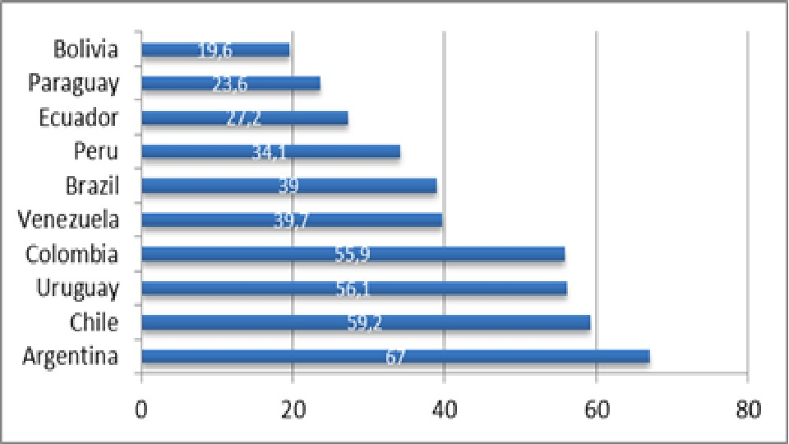
Source: www.internetworldstats.com (data updated for 2011)

In respect to the mobile telephony market, it is experimenting an accelerated growth in the region, as shown in the next chart:

Chart 2:
Mobile Telephony Penetration (%)
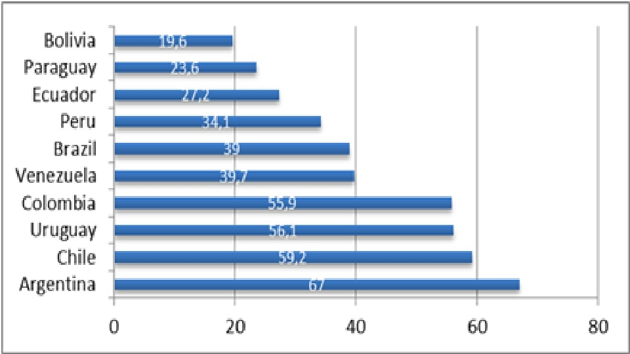

Source: www.internetworldstats.com (data updated for 2011 and, for some countries, 2013)

In regard to broadband penetration in Latin America and the Caribbean (LAC) countries, the Inter American Development Bank states that it “is much lower than in more industrialized countries, such as the OECD countries” (García Zaballos & López-Rivas 2012: 2), as well as extremely unequal due to “variations in socioeconomic and orographic conditions (…) and the high cost of the investments required for infrastructure (…) However, (…) mobile broadband has evolved very rapidly in recent years” (García Zaballos & López-Rivas 2012: 2).

Chart 3:
Broadband Internet Penetration (%)
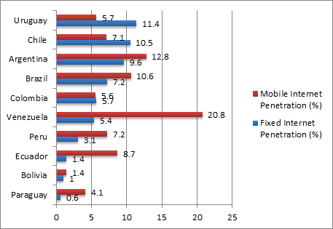
Source: ITU 2011, García Zaballos & López-Rivas 2012

As a consequence of the latter, when compared to OECD countries, connectivity in LAC is “not only low speed, but also considerably more costly (…) These factors make it very difficult to close the existing technology gap” (García Zaballos & López-Rivas 2012: 3). A study by the International Telecommunication Union (ITU) based on the Broadband Observatory of the Latin America and Caribbean Economic Commission (CEPAL) confirms this: “The number of mobile broadband subscribers, as a percentage of the total population of Latin America and the Caribbean, increased from 0.2 per cent in 2005, to 4.7 per cent in 2009, while in OECD countries this percentage went from 5 per cent to 49 per cent over the same period” (ITU 2013: 15).

Regarding the average cost of broadband in LAC countries, by 2011 it amounted to USD 72.8 dollars per Mbit/s, “in contrast to the USD 5.9 per Mbit/s for OECD countries” (ITU 2013: 15). Brazil, Peru, Ecuador, Chile, Uruguay, Argentina, and Colombia are below the average, while Paraguay and Bolivia are above. In fact, Bolivia “tops the list, where the tariff measured against the Purchasing Power Parity (PPP), amounts to USD 300 dollars per Mbit/s” (ITU 2013: 15).
Chart 4:
Broadband Speed (Mbps)
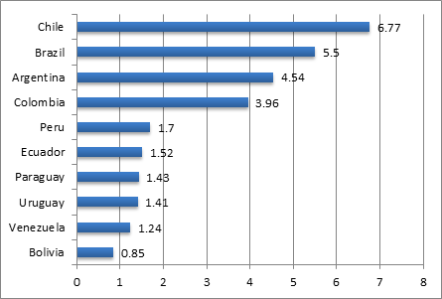
Source: Galperin and Ruzzier 2011, cited in García Zaballos & López-Rivas 2012

Chart 5:
Average Price per Mbps (USD PPP per Mbps)
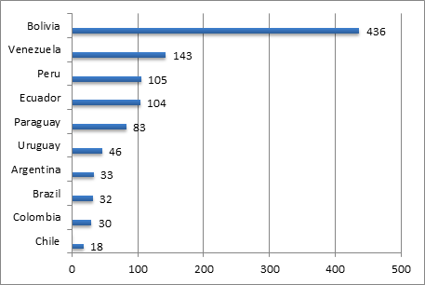
Source: Galperin and Ruzzier 2011, cited in García Zaballos & López-Rivas 2012

In terms of uplink and downlink speed, from 2010 to 2011, “South America had an effective speed increase of 53 per cent in access to Internet broadband” (ITU 2013: 16). Only Chile and Ecuador are above the South American uplink average, and just Chile and Brazil are above the downlink average. Bolivia, Peru, Uruguay, and Colombia are consistently below for both scenarios.

NEW Affordability of internet
With respect to affordability of broadband access (expressed as a percentage of average GDP per capita), to pay for access to OER, the Internet Society’s Global Internet Report for 2014 indicates that the countries paying the most for broadband include Ecuador (10.88% and ranked 106th in the world) and Bolivia (10.06% and ranked 103th in the world). Those countries most able to afford broadband access are Uruguay and (1.24% and ranked 35th in the world and Peru (1.33% and ranked 38th in the world).

Country | Affordability | Rank
Ecuador | 10.88% | 106th
Bolivia | 10.06% | 103rd
Paraguay | 6.01% | 91st
Colombia | 2.89% | 71st
Argentina | 2.29% | 67th
Chile | 2.02% | 61st
Brazil | 1.88% | 57th
Venezuela | 1.45% | 43rd
Peru | 1.33% | 38th
Uruguay | 1.24% | 35th
Data from http://www.internetsociety.org/map/global-internet-report/

García Zaballos & López Rivas (2012) consider that governments have played an important role in expanding access to broadband Internet by designing and implementing sound public policies; however, “This has underscored the need for a greater focus on strategic regulation and capacity building and applications. By generating additional broadband subscriptions, focusing on these pillars will have a larger effect on GDP, productivity, and employment” (p.15).

In sum, South American countries still have to work on improving their infrastructure for OER development, especially in countries like Bolivia, Ecuador Paraguay, and Peru. The situation of Argentina, Brazil, Chile, Colombia, and Uruguay is much better in some of the aspects described above.

2. Educational framework: Higher Education Institutions (HEI) in South America

Postsecondary education, specifically in the form of the creation of new universities, has expanded considerably during the 20th and the 21st centuries in South America. By 2013, there were xxx universities the region (Figure 3).

Figure 3: Number of Universities
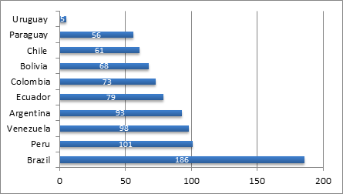
Source: Cuenca 2013a

Many of the new universities are private institutions. With the exception of Venezuela, Brazil, and Argentina, private universities outnumber public ones in South America:

Chart 4:
Private Universities vs. Public Universities (%)
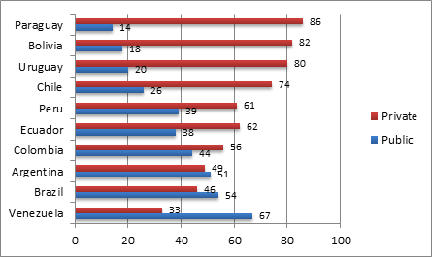
Source: Cuenca 2013a
In terms of coverage, the regional average for higher education enrolment for the whole of Latin America (19 countries) is 41%, while the OECD countries’ average is 66%. Venezuela and Argentina are above the OECD average with coverage of 78% and 68% respectively. Uruguay is very close with 65%, and the rest of countries are below this average and even below the average for Latin America, with Bolivia (38%), Paraguay (37%), Colombia (37%), Peru (34%), and Brazil (34%) at the bottom. According to Cuenca (2013), “despite the large number of private universities, the largest enrollment is in public universities. Even in countries such as Mexico and Chile, where the majority of universities are private, one-third of the country’s students are enrolled in public universities. The most special case is that of Uruguay, where 85 percent of all university students are enrolled in the country’s only public university” (p. 3). Brazil, Chile, Paraguay, and Peru have a high ratio of private enrolment, which more or less (with the exception of Brazil) corresponds to the percentage of private universities in said countries. On the other hand, more than 70% of the students in Uruguay, Argentina, Bolivia, and Venezuela attend public universities in spite of the existing private supply:

Chart 5:
University Enrolment – Private Universities (%)
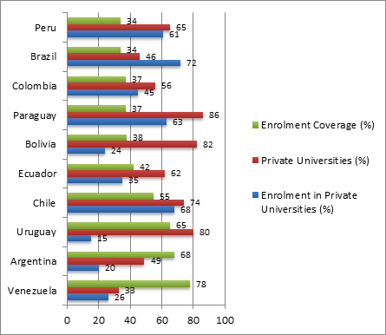
Source: Cuenca 2013a

The numbers above show that there is a growing demand for higher education (HE) in South America. The number of private HEI is growing, but most students prefer public HE, because of its affordability. This brings us to the fact of access inequality; as Cuenca states: “Latin America’s range of access to higher education is the most unequal on the planet” (...). With a Gini coefficient of 0.53, Latin America is 19% more unequal than sub-Saharan Africa, 37% more unequal than East Asia, and 65% more unequal than the developed countries (López-Calva & Lustig, 2010; Lustig, 2011). The economic, social, cultural, and political gaps between rich and poor, urban and rural, and “Indian” and “Western” continue to grow wider despite the efforts of many governments, the clamor of social movements, and warnings from academia” (Cuenca 2013a: 5).

A study by the World Bank attributes the low enrollment rate in Latin America to the following factors: “(i) affordability and lack of financing of tertiary education, (ii) insufficient and unequal access to secondary education, (iii) the lack of information, and (iv) low expectations of attending tertiary education among youth from low-income families” (Murakami & Blom 2008: 2). All of the former contribute to inequality in access to higher education. Additionally, the quality of the education is also an issue. The growth in number of universities and enrolment has come with a decline in resources and teaching (reference).

In this context, the potential of OER to widen access to quality higher education in South America is a crucial research topic. The next section describes the regulatory framework and policy initiatives in South America with regard to ICT and education.

3. Legal and policy aspects

Intellectual property policies
There are a number of norms that regulate intellectual property in South America: the Common Norm for the Andean Community (Andean Community Decision No. 351 of December 17, 1993 - Common Provisions on Copyright and Neighboring Rights), the WIPO Copyright Treaty (WCT), the WIPO Performances and Phonograms Treaty (WPPT) and the World Trade Organization (WTO) - Agreement on Trade-Related Aspects of Intellectual Property Rights (TRIPS Agreement 1994). The spirit of these norms could be understood as opposed to the open education movement, since they privilege authorship rights and not the dissemination of educational content.

By contrast only seven South American 12 sovereign states are part of the formal Creative Commons Affiliate Network (Argentina, Brazil, Chile, Colombia, Ecuador, Peru, Venezuela), which indicates that the legal infrastructure for sharing teaching and learning materials openly is not yet in place thus making OER adoption still a challenge across the whole region.

However, innovative ways of licensing intellectual or artistic work, such as Creative Commons (CC[10]), are gaining ground in the region. CC representatives in various South American countries are very active in establishing contact with government agencies, educational institutions, and NGOs in order to create awareness about the benefits of CC licenses.

Policy

In the UNESCO/COL OER survey Hoosen reports that 46% of Latin America and Caribbean countries report the presence of a strategy or policy on OER (2012:11). In the same survey reports that 41% of Latin America and Caribbean countries can identify specific OER initiatives by institutions and engaged individuals; 23% by government initiatives and 9% by private funding (Hoosen 2012: 3).

This trend is destined only to grow stronger since the potential of ICT for development has been recognized globally in the 21st century. The World Summit on the Information Society (WSIS), for instance, proposes ten goals to be achieved by 2015. Among those, two are related to primary and secondary education. In a report on the topic by UNESCO (2012), the organization states the relevance of serious involvement at the government’s level: “An important element in the sustainable success of initiatives to introduce and use ICT is the existence of a government’s formal commitment (Kozma, 2008). These commitments can take a number of forms: i) a national policy; ii) a national plan; iii) a set of regulatory provisions; and/ or iv) a regulatory institution or body (…). In Latin America and the Caribbean, 31 of 38 countries (82%) have at least one kind of formal definition of their ICT in education initiatives, while 9 (24%) have all formal definitions. These include (…) Chile, Ecuador, (…) Uruguay and Venezuela (...)” (UNESCO 2012: 7). The same report declares that 24% of the countries (in Latin America?) analyzed in it have a policy of open educational resources.

ICT in Education Policies
Lago (2012) states that the South American region has sound public policies regarding ICT: “Not a single country is lacking a national digital agenda” (p. 208). In the same line, Rozo (2012) indicates that the Ministries of Education of the countries forming the Andean region (Bolivia, Colombia, Ecuador, Peru, and Venezuela) as well as Argentina, Brazil, and Chile promote the use of ICT through strategic programs targeted at all the educational levels. A constant … across countries is the emphasis on addressing the “brecha digital” (digital divide) through digital inclusion.

In 2010, Argentina launched the country’s National Telecommunication Plan, Argentina Conectada (Connected Argentina). The strategic orientations of Argentina Conectada are “digital inclusion; optimizing use of the radio-frequency spectrum; developing universal service; national production and creation of employment in the telecommunication sector; training and research in telecommunication technologies; infrastructure and connectivity; and capacity building”. The plan has a major focus on the promotion of digital inclusion for traditionally excluded groups of people as well as on developing content useful for educational purposes, among others. Also in 2010, the Programa Conectar Igualdad (Connecting Equality Program) was launched. Conectar Igualdad is a national program implemented mainly in public secondary schools and teacher training institutions with the main goal of promoting digital inclusion. It provides each student and teacher with netbooks and pedagogical orientations for their use, while implementing teacher training actions and developing educational content. All the beneficiaries of the program can take the netbooks home, allowing other members of the household to have access to a computer and to the Internet.

Bolivia has the Programa Nacional de Nuevas Tecnologías de Información y
Comunicación en la Educación – NTICs Bolivia (National Program for New Information and Communication Technologies in Education – NICTs Bolivia). The program’s objectives include providing each school teacher with a computer, developing community centers (“telecentros”) and an educational portal, and providing teacher training.

In the case of Brazil, “the basic concept of government action on digital inclusion may be found in the National Broadband Plan - “Programa Nacional de Banda Larga” (PNBL)” from 2010 (Rossini 2012: 1). Additionally, Cuenca (2013) states that from 1998 on, the Ministry of Education has regulated different aspects of distance education. Currently, the Plano de Desenvolvimento da Educação – PDE (Education Development Plan) presents a set of 40 strategic actions of the Ministry of Education, that as such has driven the implementation of a number of programs, e.g. a digital inclusion program; the aims of which include efforts to install computers and multimedia labs in all public schools, the production of multimedia digital content intended to support schools and students through the Portal do Professor (Teacher’s Portal) or the Banco Internacional de Objetos Educacionais (International Database of Educational Resources). “Initiatives such as Interactive Virtual Network of Education (Rede Interativa Virtual de Educação – RIVED) were set up as a network of virtual learning objects rather than of open educational resources.” (Dos Santos 2011: 15).

In 2013, Chile presented the Agenda Digital ImaginaChile (Digital Agenda ImagineChile). It is a very ambitious plan that envisions Chile as a regional leader in the use of digital technologies to promote development. ImaginaChile has five strategic axis: connectivity and digital inclusion; education and training; entrepreneurship and innovation; context for digital development; and services and applications. The first of them, proposes initiatives towards improving Internet connectivity and speed through the expansion of broadband, as well as the adaptation of the existing normativity to current objectives. Regarding education and training, the Agenda includes various initiatives concerning teacher training, the improvement of infrastructure and connectivity for better learning, and the development of digital resources and online education.

Colombia has developed the Plan Vive Digital (Live Digital Plan), which focuses on expanding Internet access and connectivity across the country, implementing community computer centers, and teacher training in ICT use, among other goals. Within this framework, the country has launched the Programa Computadores para Educar (Computers for Education Program), which provides schools with new and refurbished computers while training teachers in the use of ICT in the classroom.

The Ministry of Education of Colombia put in place the Sistema Nacional de Innovación Educativa con Uso de TIC (National System of Educational Innovation Using ICT), which has developed the Estrategia Nacional de Recursos Educativos Digitales Abiertos (National Strategy of Digital Open Educational Resources). The strategy is specifically directed to higher education and favors a collaborative approach towards the production and use of OER to fight against inequality and the digital divide. One of the initiatives of the Strategy is the creation of the Red Nacional de Repositorios Institucionales de Recursos Educativos Digitales Abiertos (National Network of OER Institutional Repositories), with extensive information regarding the procedures to follow to participate in such network.

In Ecuador, there is a Programa de Acceso Universal a las Tecnologías de Información y Comunicación – TIC (ICT Universal Access Program) oriented to reduce the digital divide. It includes the delivery of Internet access and computers to urban and rural schools, the implementation of Infocentros Comunitarios (community computer centers), and the deployment of Aulas Móviles (Mobile Classrooms) which allow all citizens to have access to ICT. Additionally, a Plan Nacional de Banda Ancha (National Broadband Plan) is being launched in 2014.

Peru has developed an Agenda Digital 2.0 (Digital Agenda 2.0), launched in 2011, with eight different objectives. Some of them are explicitly targeted at inequality issues (differences in access, connectivity), while others tackle educational issues and promote the strengthening of digital literacy among the population, the creation of digital educational content for every educational level, and the use of ICT in scientific research. The Agenda includes a Plan Nacional de Banda Ancha en el Perú (National Broadband Plan in Peru).

In the case of Uruguay, there is also available an Agenda Digital Uruguay 2011-2015 (Digital Agenda Uruguay 2011-2015). In a similar way as the previous Agendas we have described, Uruguay’s aims for improving access and connectivity through broadband, and for developing the full potential of ICT in all the educational levels. Plan CEIBAL is one of the pillars of the latter; by 2014 it has delivered 1 million computers to students and teachers in public schools.

In sum, public policies regarding ICTs in South America constitute a solid foundation for the development of OER initiatives. Nevertheless, it is important to differentiate which policies are actually being implemented and getting results, and which ones are still basically just good intentions.

4. OER Programs and Initiatives

There are a number of OER initiatives in South America. Most of them articulate efforts from European institutions or multinational organizations looking to promote the development and use of OER in the region.

It is worth noting the existence of the Red Latinoamericana de Portales Educativos – RELPE (Latin American Network of Educational Portals – RELPE). 16 Latin American countries are part of RELPE since 2004 through the educational portals of their respective Ministries of Education. The network encourages the shared use of the contents developed by each country, as well as the creation of common repositories. Currently, RELPE is researching teacher-training experiences using ICT.

Among RELPE partner institutions are the Agencia Española de Cooperación Internacional para el Desarrollo – AECID (Spanish International Cooperation for Development Agency), Organización de Estados Iberoamericanos – OEI (Organization of Ibero American States), the Inter American Development Bank – IADB, the Comisión Económica para América Latina y el Caribe – CEPAL (Economic Commission for Latin America and the Caribbean), and the International Development Research Centre – IDRC. Its South American members include Argentina (www.educ.ar), Bolivia (www.educabolivia.bo), Brazil (http://portaldoprofessor.mec.gov.br), Colombia (www.colombiaaprende.edu.co), Chile (www.educarchile.cl), Ecuador (www.educarecuador.gob.ec), Paraguay (www.paraguayaprende.edu.py), Peru (www.perueduca.pe), Uruguay (www.uruguayeduca.edu.uy), and Venezuela (http://portaleducativo.edu.ve).

Most portals have a similar structure, with sections for students, families (or parents), and teachers. The teachers’ section offers courses and tutorials, shared experiences from other teachers, and varied digital resources. It has proven to be a useful tool in delivering massive online courses as part of in-service teacher training.

Besides RELPE, we can find other interesting initiatives. Some of them focus on open access to scientific research, others on developing repositories of learning objects, and others widen their goals to include the creation of networks that work collaboratively in strengthening the OER movement. We described some of them in the following lines.

· Proyecto LATin – Iniciativa Latinoamericana de Libros de Texto Abiertos
(LATin Project – Latin American Initiative for Open Textbooks)
www.latinproject.org

The LATin Project is part of the ALFA Program, which promotes cooperation between the HEIs of Europe and Latin America. The Project’s main goal is the creation of collaborative open textbooks, specifically designed for the region, by local authors. It is hoped that underprivileged students can benefit from the access to free textbooks while they attend HEI.

LATin Project conceives of open textbooks as complex educational resources that include multimedia content that allow for interaction. The modality used to develop the open textbooks involves calls for proposals. The authors whose proposals are selected, develop the open textbooks on a special platform (Booktype) and adhere to Creative Commons licenses so that the books can be transformed and adapted by their users. Some of the accepted proposals to date include topics like Software Projects Management; Public Policies, Gender, and Human Rights in Latin America; Computer Assisted Collaborative Learning; and Operational Systems.

The European HEI involved in the project are Katholieke Universiteit Leuven (KUL) from Belgium, Universidad de Alcalá from Spain, and Université Paul Sabatier from France. The participating South American HEI are the following: Universidad Nacional de Rosario (Argentina), Universidade Presbiteriana Mackenzie (UPM) from Brazil, Universidad Austral de Chile (UACh) from Chile, Universidad del Cauca (UNICAUCA) from Colombia, Escuela Superior Politécnica del Litoral (ESPOL) from Ecuador, Universidad Católica San Pablo (UCSP) from Peru, Universidad de la República (UDELAR) from Uruguay, and Universidad Central de Venezuela (UCV) from Venezuela. The Karisma Foundation from Colombia is part of the initiative also.

It will be of interest to evaluate the quality of the resources developed as well as to document their future use and adaptation.

· LACLO – Comunidad Latinoamericana de Objetos de Aprendizaje
(LACLO – Latin American Community on Learning Objects)
www.laclo.org

LACLO defines itself as an “open community integrated by people and institutions interested in research, development, and application of technologies related to learning objects in the Latin American educational sector”. Its mission is to explain regional initiatives in order to raise awareness about the potential of such technologies.

From 2010 on, LACLO organizes annual seminars where new research is presented. It also hosts the Latin American Federation of Learning Object Repositories – LA FLOR (http://laflor.laclo.org), which offers educational material in Spanish, Portuguese, and English. Most of the materials available in this repository are PDF documents, PowerPoint presentations and videos developed by the Escuela Superior Politécnica del Litoral – ESPOL (Guayaquil, Ecuador), and from Colombia Aprende, the educational portal of the Ministry of Education of Colombia. There is no information in the website regarding the criteria used to select these resources nor regarding their use.

· Miríada X
www.miriadax.net

Miríada X is a platform where faculty members from Ibero American HEIs create and offer Massive Open Online Courses (MOOCs). This initiative is promoted by Telefónica Learning Services and Universia, a network of Spanish and Portuguese-speaking HEIs. Any teacher working in a university affiliated to the Universia network can post courses on the platform, which range from Sciences to Health, Law, and Humanities, among others. According to Cuenca (2013b), “any professor from a range of more than 1200 universities from 23 Ibero American countries, can create and disseminate its own course. Since its inception, this platform has grown rapidly, and now offers 58 courses from 18 universities, with more than 300.000 participating students, from which around 40.000 completed their courses satisfactorily” (Cuenca 2013: 5-6).

Some of the South American HEIs offering courses in Miríada X are the following: Universidad San Martín de Porres (Peru), Universidad de Ibagué (Colombia), Universidad Tecnológica de Pereira (Colombia), Universidad Católica Santo Toribio de Mogrovejo – Chiclayo (Peru), Universidad Blas Pascal – Córdoba (Argentina).

· Red CLARISE – Comunidad Latinoamericana Abierta Regional de Investigación Social y Educativa / SINED-CLARISE
(CLARISE Network – Latin American Regional Open Community for Social and Education Research / SINED-CLARISE)
https://sites.google.com/site/redclarise/

The CLARISE Network defines itself as a community of practice integrating researchers with a common interest in raising awareness and promoting access to OER produced in Latin America. The network has members from HEIs in Mexico, Argentina (Universidad Nacional de Mar del Plata, Universidad Nacional de San Juan, Universidad Nacional de Córdoba) Colombia (Universidad de la Sabana), Uruguay (Universidad de la República), and Costa Rica.

During 2011 and 2012 and with the leadership of researchers from the Tecnológico de Monterrey (Mexico), CLARISE conformed an international community of researchers on OER, trained those researchers in the development and use of OER, and disseminated research outcomes through its website.

From 2013 on, the CLARISE Network is known as the SINED-CLARISE initiative (SINED is the Sistema Nacional de Educación a Distancia – National System of Distance Education – of Mexico).

· Scientific Electronic Library – SciELO
www.scielo.org

SciELO “is a Latin American and Caribbean Scientific Electronic Library that provides global visibility to the academic publishing of scientific journals. SciELO was created in 2007 to store, disseminate and evaluate scientific literature in electronic format. It comprises a network of 15 national and two thematic open access journal collections that are regularly published online (…) It was originally created by two Brazilian research organizations” (Cobo 2012: 76). By September 2013, SciELO statistics were as follows:
• 1,057 journals
• 29,990 issues
• 441,396 articles
• 9,698,531 citations.

· Red de Bibliotecas Virtuales de Ciencias Sociales de América Latina y El Caribe del Consejo Latinoamericano de Ciencias Sociales – CLACSO
(Latin American and Caribbean Network of Virtual Libraries in Social Sciences from CLACSO)
http://biblioteca.clacso.edu.ar/ingreso-informacion/actualizacion-profesional/bibliotecas&repositorios/

CLACSO, based in Argentina, is conformed by 300 member institutions in 20 Latin American and Caribbean countries. Since 1998, CLACSO’s network of virtual libraries offers open access to full-text books, peer-reviewed journals (in association with RedALyC), and a multimedia portal with audio files, video, photographs, and on-line radio stations.

Additionally, CLACSO acts as an advocate to promote open access to publicly funded research outcomes, including activities oriented towards adapting the existing legislation in Argentina.

· RedALyC
http://redalyc.org

REDALYC “is a Latin American and Caribbean network of open access scientific journals, started in Mexico in 2003. It was created to build a scientific information system to leverage access to and visibility of the scientific knowledge produced in, and about, Latin America. Nowadays, Redalyc is an information system that also evaluates the scientific and editorial quality of scientific knowledge production in Ibero-America. (…) It was created by the Universidad Autónoma del Estado de México” (Cobo 2012: p.76).

By September 2013, REDALYC statistics were as follows:
• 858 scientific journals
• 23,523 issues
• 299,128 full-text articles.

· COLABORA – Comunidad Latinoamericana de Bibliotecas y Repositorios Digitales
(COLABORA – Latin American Community of Libraries and Digital Repositories)
http://www.saber.ula.ve/colabora/

COLABORA is at the same time a research community and a repository. The South American countries included in COLABORA are Argentina, Brazil, Chile, Colombia, Ecuador, Peru, and Venezuela. Some of the institutions that take part in the community are also part of other initiatives included in this review: CLACSO from Argentina, Universidade de São Paulo from Brazil, Universidad Austral from Chile, EAFIT from Colombia, Escuela Politécnica del Litoral from Ecuador, Universidad Peruana de Ciencias Aplicadas from Peru, and Universidad de los Andes from Venezuela.

· OportUnidad Project
www.oportunidadproject.eu

The OportUnidad Project is funded by the European Commission‘s ALFA program with the goal of developing “between 2012-2014, a higher education inter-institutional action research programme in Latin America to promote the use, re-utilisation, production and sharing of OER” (Cobo 2012: 76). The specific objectives of OportUnidad, as stated by Cobo (2012) include raising awareness about OER, defining an agenda for OER use and re-use, teacher training in the use of OER, as well as providing assisted start-up of OER practices in university courses.

It is hoped that more than 50 HEI from Latin America will take advantage of the OportUnidad Project under the guidance and leadership of “the Universidade Federal Fluminense (Brazil), the Universidad Estatal a Distancia (Costa Rica), the Universidad Técnica Particular de Loja (Ecuador), the Fundación Uvirtual (Bolivia), the Universidad Virtual del Tecnológico de Monterrey (Mexico), the Universidad de la Empresa (Uruguay) and the Universidad Inca Garcilaso de la Vega (Peru). There are also four partner institutions from the EU: the Università degli Studi Guglielmo Marconi (Italy), the Universitat Oberta de Catalunya (Spain), the Faculdade de Letras da Universidade de Lisboa (Portugal), and the University of Oxford (UK)” (Cobo, 2012, p.77).

· OCW-Universia
http://ocw.universia.net/es/

Universia is a network of 1262 HEIs in 23 Ibero American countries. The initiative began in 2000 in Spain with 35 Spanish Universities. OCW-Universia is a sub-project of the network, launched in 2005, that links its member institutions’ OCW sites to the OCW-Universia site. According to this website, the experience has been very positive: while the courses available in 2005 were 100, they increased to 1500 in 2012.

According to OCW-Universia, the following 16 South American HEIs offer open courseware:
· Argentina: Universidad Argentina de la Empresa, Universidad Nacional de Córdoba.
· Brazil: Universidade Estadual de Campinas, Universidade Metodista de São Paulo.
· Chile: Pontificia Universidad Católica de Chile, Pontificia Universidad Católica de Valparaíso, Universidad de Chile.
· Colombia: Universidad de Manizales, Universidad del Valle, Universidad Eafit, Universidad Icesi, Universidad Industrial de Santander.
· Peru: Universidad Nacional San Agustín de Arequipa, Universidad Nacional de Ingeniería, Universidad de Ciencias Aplicadas.
· Venezuela: Universidad Central de Venezuela.

· RIATE – Red Iberoamericana de TIC y Educación
(RIATE – Ibero American Network on ICT and Education)
www.riate.org

This Spanish network articulates Spanish-speaking countries’ efforts in the development and exchange of digital resources for education. Among its lines of action are teacher training, and the dissemination of news and publications regarding ICT in education. Additionally, RIATE offers some courses in ICT-related subjects.

· Mapa Mundial de REA
(World Map of OER)
http://cedec.ite.educacion.es/es/kubyx/2012/12/13/82-mapa-mundial-de-rea-icomo-y-por-que

This is an initiative developed by the Ministry of Education, Culture, and Sports from Spain, and two institutions related to educational technology. It is not a South American initiative, but it will surely involve HEIs from the region in the near future.

· Temoa
www.temoa.info/

Temoa “is a public catalogue that indexes OER from top universities worldwide. Its aim is to offer a public and multilingual catalogue built and reviewed by experts, and to simplify the finding of OER by providing specialized and collaborative search tools. It contains selected educational resources, described and evaluated by an academic community, and categorized by area of knowledge, educational level and language, among other criteria” (Cobo 2012: 76). Temoa is not a South American program, but an initiative of the Tecnológico de Monterrey (Mexico). It is included in this review because of its potential for the OER movement in South America.

By September 2013, Temoa statistics were as follows:
· 529,002 educational resources
· 524,411 peer-reviewed
· 4,348 resources used in class lectures
· 1,549 courses, topics and activities
· 20,346 reviews
· 9,389 members.

· Portal Educativo de las Américas – Organización de Estados Americanos (Educational Portal of the Americas – Organization of American States)
http://www.educoas.org/default2.aspx?q=%3Flang=es

The Organization of American States – OAS hosts this portal that offers online courses in English, Spanish, and Portuguese. The OAS is developing an “OER Meta-portal”.

· Educared
www.educared.org
Educared is an initiative of the Telefónica Foundation in Argentina, Brazil, Chile, Colombia, Venezuela, Spain, Mexico, and Peru to improve the quality of education. Educared is not an OER initiative per se, but the program focuses its actions in promoting the use of ICTs for education, and offers free online resources specially developed by the program.

· Some national initiatives in South America

· Argentina
Recursos Didácticos de la Biblioteca Nacional del Maestro
www.bnm.me.gov.ar/e-recursos/recursos_didacticos
Gleducar
http://wiki.gleducar.org.ar/index.php/P%C3%A1gina_Principal
ORT Campus Virtual Argentina http://www.virtualcampuses.eu/index.php/ORT_Campus_Virtual
ColegioVirtual.org
http://www.virtualcampuses.eu/index.php/Argentina

· Brazil
FrancoClic
http://francoclic.mec.gov.br
Banco Internacional de Objetos Educacionais http://objetoseducacionais2.mec.gov.br
Pearson Copyleft
www.copyleftpearson.com.br
Recursos Educacionais Abertos Brasil
http://rea.net.br
Veduca
www.veduca.com.br
Interactive Virtual Network of Education – Rede Interativa Virtual de Educação
http://rived.mec.gov.br
Fundação Getulio Vargas – FGV Online
http://www5.fgv.br/fgvonline/

· Chile
APROA – Aprendiendo con Objetos de Aprendizaje
www.aproa.cl

· Colombia
Universidad Nacional de Colombia – Repositorio Institucional
www.bdigital.unal.edu.co
Eduteka
www.eduteka.org
Banco de Objetos de Aprendizaje
http://aplicaciones.virtual.unal.edu.co

· Ecuador
Repositorio de la Biblioteca de Ingeniería y Electrónica de la Escuela Politécnica Nacional, Facultad de Ingeniería Eléctrica y Electrónica
http://bieec.epn.edu.ec:8180/dspace/
Repositorio Institucional de la Universidad de Guayaquil
http://repositorio.maeug.edu.ec/
Repositorio de la Universidad Técnica Particular de Loja
http://repositorio.utpl.edu.ec

· Venezuela
Conocimiento Libre y Educación – Red CLED
http://cled.org.ve
Repositorio de Objetos de Aprendizaje
http://roa.mppeu.gob.ve

5. Research
To-date much of the research on OER adoption in South America has been slanted towards general reviews of OER projects (e.g. Dos Santos 2011, Rossini 2012) but very little is empirical in nature. Some research is available only in Spanish or Portuguese (e.g. Astudillo, Willging & Garcia 2011; Rozo & Prada 2012).

6. Final considerations

· With the exception of a few countries, most South American nations need to drastically improve their infrastructural and technical conditions: Internet penetration is still low (especially in rural and marginalized areas), broadband speed is inadequate and its cost is high. OER adoption will be delayed until these conditions are upgraded.
· As a result of the expansion of primary and secondary education, the demand for post secondary education intensified in South America. The rate of enrollment in HEIs has also increased. Nevertheless, the poor and the indigenous are still struggling with access to tertiary education. OER could arguably play an important role in granting access to higher education to those populations. We believe it is important to maintain a strong institutional framework to support the students benefiting from OER:
o OER initiatives should be tailored to the needs of specific groups of students and provide proper accreditation. In this respect, Macintosh, McGreal and Taylor (2011), cited in Knox (2013), warn about the fact that OER “could lead to a new form of elitism where the perception associated with online degrees using OER would not command the same respect as campus-based alternatives” (Knox 2013: 4).
o Underprivileged students using OER “are expected to achieve the same levels of attainment without the contact or supervision received by those attending university. The inequality does not just lie in the recognition of the qualification, but also in the range and quality of the guidance and support” (Knox 2013: 5). That is why a strong institutional framework is recommended.
· In terms of the regulatory and policy framework, most South American countries have achieved major developments in the last years. There are, although, considerable differences among them in relation to the political, technical, and bureaucratic capacity to make real advances. It is especially important to provide solid opportunities for teachers and professors in order to develop their abilities to use and create digital education resources, and to embrace the concept of open education and open access.
· The existing international OER initiatives in South America are promising, however, it seems clear that there are some “strong” member countries (and their respective HEIs) and some “weak” ones. As Kanwar, Kodhandaraman & Umar (2010) express, it is imperative for universities and research institutions involved in OER projects to develop an ICT policy, to fix a policy on copyright issues, and to provide incentives for members for OER creation, use, and research.

References

Alperin, J. P., Fischman, G., & Willinsky, J. (2008). Open access and scholarly publishing in Latin America: Ten flavours and a few reflections. Liinc Em Revista, 4(2).
http://revista.ibict.br/liinc/index.php/liinc/article/view/269

Astudillo, G. J., P. Willging & P. García (2011). Estado del arte de los repositorios de materiales educativos en Latinoamérica. Paper presented at the VI Congreso de Tecnología en Educación y Educación en Tecnología.
http://sedici.unlp.edu.ar/bitstream/handle/10915/18431/Documento_completo__.pdf?sequence=1

Cobo, C. (2012). Conditions required to implement OER practices in Latin American Higher Education. Cambridge 2012: Innovation and Impact - Openly Collaborating to Enhance Education, 16-18 April, Cambridge, UK (pp-71-79). http://www.open.ac.uk/score/files/score/file/Conference%20Proceedings%20Cambridge%202012.pdf

Cobo, C., C. Stefanelli, M. Maina & I. Mascitti (2012). OportUnidad - Open educational practices: a bottom-up approach in Latin America and Europe to develop a common Higher Education Area. Pp.304-310. Cambridge 2012: Innovation and Impact - Openly Collaborating to Enhance Education, 16-18 April, Cambridge, UK (pp.304-310). Available online: http://www.open.ac.uk/score/files/score/file/Conference%20Proceedings%20Cambridge%202012.pdf [September 9th, 2013]

Comisión de Planificación y Coordinación Estratégica del Plan Nacional de “Argentina Conectada” (n/d). Plan Nacional de Comunicaciones “Argentina Conectada”
http://www.argentinaconectada.gob.ar/pv_obj_cache/pv_obj_id_BBF1FD65215BF5C6569C425C3A40C9D624C01C00/filename/0000055630.pdf. Retrieved on Nov. 26, 2013.

Cuenca, R. (2013a). Higher Education for Latin America: Two Challenges in a Field of Opportunities. In Stead, V. Ed. International Perspectives on Higher Education Admission Policy. New York, NY: Peter Lang, (forthcoming).

Cuenca, R. (2013b). E-learning, educación superior y competitividad en Iberoamérica. (Manuscript).

D’Antoni, S. (2009). Open Educational Resources: reviewing initiatives and
issues, Open Learning: The Journal of Open, Distance and e-Learning, 24:1, 3-10.

Dos Santos, A.I. (2011). Open Educational Resources in Brazil: State-of-the-Art, Challenges and Prospects for Development and Innovation. UNESCO Institute for Information Technologies in Education.
http://iite.unesco.org/publications/3214695

Dos Santos, A., C. Cobo & C. Costa [org]. (2012). Compendium - Open Educational Resources: Cases from Latin America and Europe in Higher Education. Niterói: CEAD-UFF,
http://ora.ox.ac.uk/objects/uuid%3Aa33cf84c-9c37-4906-a8f9-4628b9dae4d5/datastreams/ATTACHMENT01

García Zaballos, A. & López-Rivas. (2012, November). Socioeconomic Impact of Broadband in Latin American and Caribbean Countries. Inter American Development Bank. (IDB Technical Note; 471). http://www.iadb.org/intal/intalcdi/PE/2013/11427.pdf . Retrieved on Nov. 30, 2013.

Hodgkinson-Williams C. (2013). Research into Open Educational Resources for Development in Post-secondary Education in the Global South (ROER4D). Proposal to IDRC. Cape Town: University of Cape Town. (Manuscript).

Hoosen, S. (2012). Survey on Governments’ Open Educational Resources (OER) Policies. Prepared for the World OER Congress, June 2012. http://www.col.org/PublicationDocuments/Survey_On_Government_OER_Policies.pdf [Last accessed 16 August 2014]

International Telecommunication Union – ITU (2013). Study on international Internet connectivity Focus on Internet connectivity in Latin America and the Caribbean. Geneva: ITU.
http://www.itu.int/en/ITU-D/Regulatory-Market/Documents/International%20Internet%20Connectivity%20in%20Latin%20America%20and%20the%20Caribbean.pdf

Kanwar, A., Kodhandaraman, B. & Umar, A. (2010). Toward Sustainable Open Education Resources: A Perspective from the Global South. American Journal of Distance Education, 24(2), 65-80.

Knox, J. (2013): Five critiques of the open educational resources movement. Teaching in Higher Education. http://www.tandfonline.com/doi/abs/10.1080/13562517.2013.774354#preview

Lago, S., A. Marotias & S. Amado (2012). Inclusión digital en la educación pública argentina. El programa Conectar Igualdad. Revista Educacion y Pedagogía, Vol. 24, Nº. 62. Pp. 205-218.
http://aprendeenlinea.udea.edu.co/revistas/index.php/revistaeyp/article/view/14204/12547 . Retrieved on Dec. 20, 2013.

Murakami, Y. & A. Blom (2008). Accessibility and Affordability of Tertiary Education in Brazil, Colombia, Mexico and Peru within a Global Context. The World Bank – Latin America and Caribbean Region. Human Development Sector. Policy Research Working Paper 4517.
http://siteresources.worldbank.org/EDUCATION/Resources/278200-1099079877269/547664-1099079956815/wps4517.pdf

Rossini, C. (2012, June). Brazilian Policy on Digital Inclusion and Access to Digital Creative Contents. https://oerknowledgecloud.org/?q=content/brazilian-policy-digital-inclusion-and-acess-digital-creative-contents

Rossini, C. (2009/2010) Green Paper: The State and Challenges of OER in Brazil: From Readers to Writers? http://www.meducationalliance.org/sites/default/files/oer-brazil-100101.pdf [Last accessed 15 August 2014].

Rozo, A. C. & M. Prada (2012). Panorama de la formación inicial docente y TIC en la Región Andina. Revista Educación y Pedagogía, Vol. 24, 62, 191-204.
http://aprendeenlinea.udea.edu.co/revistas/index.php/revistaeyp/article/view/14203/12546 . Retrieved on Dec. 20, 2013.

Torres, N.P.M. (2013). Embracing openness: The challenges of OER in Latin American education. Open Praxis, 5(1), 81–89. http://openpraxis.org/index.php/OpenPraxis/article/view/33

Trucano, M. (2013). Surveying ICT use in education in Latin America & the Caribbean.

http://blogs.worldbank.org/edutech/node/692

UNESCO. (2012). ICT in Education in Latin America and the Caribbean. A regional analysis of ICT integration and e-readiness. Available:
http://www.uis.unesco.org/Communication/Documents/ict-regional-survey-lac-2012-en.pdf

http://www.internetsociety.org/map/global-internet-report/ [Accssed 15 August 2014]
http://www.internetsociety.org/map/global-internet-report/ [Accssed 15 August 2014]
http://en.wikipedia.org/wiki/List_of_sovereign_states_and_dependent_territories_in_South_America
https://wiki.creativecommons.org/CC_Affiliate_Network
Adapted from Smith & Casserly 2006: 8 by Hodgkinson-Williams 2013.
There is no research exclusive to South America on this topic.
Ideally, Spanish-speaking and Portuguese-speaking communities.
See Trucano 2013 for an analysis on ICT readiness for education in Latin America and the Caribbean, although the focus is on primary and secondary education.
www.internetworldstats.com
http://www.wipo.int/wipolex/en/text.jsp?file_id=223493
http://www.wipo.int/treaties/en/text.jsp?file_id=295157
http://www.wipo.int/treaties/en/text.jsp?file_id=295477
http://www.wipo.int/wipolex/en/other_treaties/parties.jsp?treaty_id=231&group_id=22
See Hoosen 2012 for information on some OER policies of some South American countries.
In: http://www.itu.int/net/itunews/issues/2011/07/24.aspx
The full document is avilable at http://www.argentinaconectada.gob.ar/pv_obj_cache/pv_obj_id_BBF1FD65215BF5C6569C425C3A40C9D624C01C00/filename/0000055630.pdf
www.conectarigualdad.gob.ar
A presentation about the topic can be found in http://www.slideshare.net/ravsirius/ntic-min-educacion-bolivia
www.desarrollodigital.gob.cl
http://www.mintic.gov.co/index.php/vive-digital
http://www.computadoresparaeducar.gov.co/
http://www.telecomunicaciones.gob.ec/plan-de-acceso-universal-y-alistamiento-digital/
http://www.telecomunicaciones.gob.ec/plan-nacional-de-desarrollo-de-banda-ancha/
http://www.codesi.gob.pe/docs/AgendaDigital20_28julio_2011.pdf
http://agesic.gub.uy/innovaportal/file/1443/1/agesic_agendadigital_2011_2015.pdf
http://www.ceibal.org.uy/
http://www.relpe.org/
On open access and scholarly publishing in Latin America see Alperin, Fischman & Willinsky (2008).
The last call for proposals ended on August 2013. Besides the platform for textbook development, authors can interact through a social network.
The Universidad Autónoma de Aguascalientes (UAA) from Mexico is also part of this Project.
Own translation from LACLO’s website www.laclo.org.
Telefónica is the largest telecommunication company in Spain and Latin America.
A full list is available at http://www.saber.ula.ve/colabora/index.php/grupostrabajo/investigadores-institucion.
For a more detailed description of OportUnidad Project see Cobo, Stefanelli, Maina & Mascitti (2012).
http://ocw.universia.net/es/instituciones-integrantes-iberoamericanas-opencourseware.php
http://ocw.unc.edu.ar/
http://www.ocw.unicamp.br/
www.metodista.br/eduCommons
http://www7.uc.cl/ocw/
http://ocw.pucv.cl/
http://www.lapetus.uchile.cl/lapetus/universia/index.htm
http://ocw.univalle.edu.co/ocw
http://www.icesi.edu.co/ocw
http://ocw.uis.edu.co/
http://www.unsavirtual.edu.pe:8090/
http://ocw.uni.edu.pe/ocw
www.temoa.info/node/42101
http://www.educoas.org/default2.aspx?q=Meta-Portal-Es
Most of them are included in the OER Repositories World Map (https://www.zeemaps.com/map?group=562530) and in Dos Santos, Cobo & Costa 2012.

