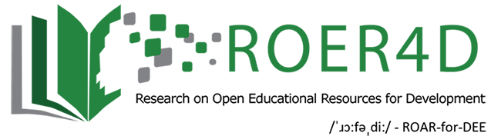
DATASET DESCRIPTION

Faculty perceptions of OER in India
Sanjaya Mishra and Alka Singh
Commonwealth Educational Media Centre for Asia smishra@col.org; alka@cemca.org.in
August 2016

This study aims to map the current preconceptions and behavioural determinants that influence academics’ engagement with Open Educational Resources (OER) in India. The key objectives of this research were to examine teachers’ attitudes towards OER in select Indian universities, establish teacher perspectives on OER use in order to establish the uptake of OER in India, identify barriers to the creation and use of OER in India, identify the factors motivating teachers’ uptake of OER in India, analyse teachers’ perceptions of quality of OER in India, and investigate relationships amongst teachers’ attitudes, motivation, perceptions of quality and barriers to use OER. The project utilised a mixed methods approach consisting of a survey and interviews conducted with academics from four Indian universities. The resultant dataset includes a qualitative component (interview transcripts) and a quantitative component (survey data).

This published dataset is comprised of the teacher survey instrument and accompanying microdata, and the teacher survey interview schedule with accompanying microdata. Microdata from the 27 interviews conducted have been combined into a single file.

The dataset is considered to be of potential interest to higher education teachers, administrators and policy-makers in higher education institutions, particularly in the context of India.

The file-naming convention adopted in this dataset categorises research instruments and associated microdata files by (1) research process, (2) whether instrument or microdata. An overview of this categorisation is provided as Appendix A.

This is Sub-Project 3 of the Research on Open Educational Resources for Development (ROER4D) programme. The work was carried out with the aid of a grant from the International Development

Research Centre, Ottawa, Canada, and is licensed under a Creative Commons Attribution Share- Alike 4.0 International (CC BY-SA 4.0) licence.
__

Appendix A: Overview of research process components mapped to file descriptions and file names

Research process | File description | File name
Teacher survey | Instrument: Teacher survey questionnaire | fpoi-2015-2015
 | Microdata for the teacher survey | q-fpoi-2015-2015-v2
Teacher interviews | Instrument: interview schedule for teacher interviews | fpoi-2014-2015-interview-instrument
 | Microdata from teacher interviews | fpoi-2014-2015-interview

