Standard echocardiography versus handheld echocardiography for the detection of subclinical rheumatic heart disease: A systematic review and meta-analysis of diagnostic accuracy
Figures:
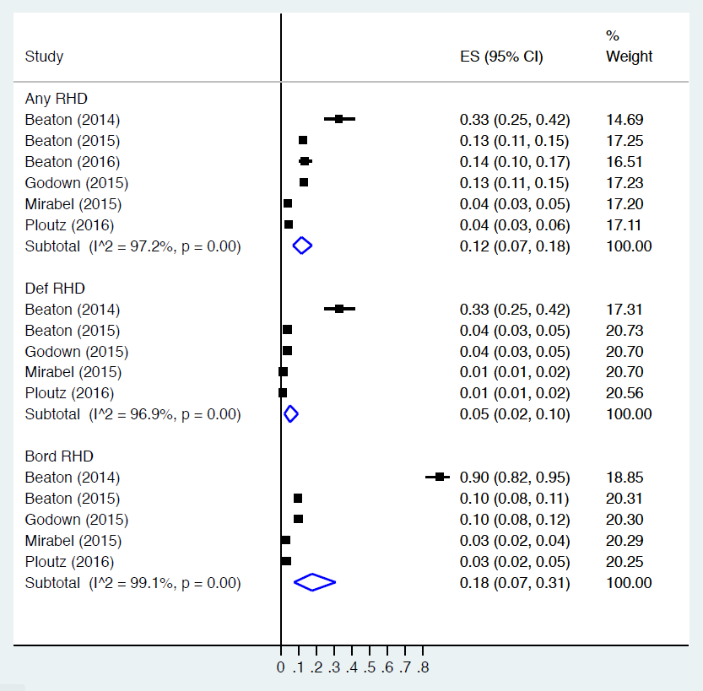

Fig 1. Forest plot of prevalence estimates*
*All pooled prevalence estimates were generated using RevMan software.

Fig 2. Forest plot of sensitivity and specificity of handheld echocardiography for any RHD

Fig 3. Summary ROC plot of sensitivity versus specificity of handheld echocardiography for any RHD

Fig 4. Forest plot of sensitivity and specificity of handheld echocardiography for definite RHD

Fig 5. Summary ROC plot of sensitivity versus specificity of handheld echocardiography for definite RHD

Fig 6. Forest plot of sensitivity and specificity of handheld echocardiography for borderline RHD

Fig 7. Summary ROC plot of sensitivity versus specificity of handheld echocardiography for borderline RHD

Fig 8. Summary ROC plot of sensitivity versus specificity of handheld echocardiography for any RHD according to echocardiographer expertise

