Consent form for digital storytelling project EGS3021F
I, _________________________________________ give my consent to be
interviewed/photographed/ video recorded by ____________________________________.
I understand that this student will be using this material to make a digital story that will be shared in the classroom.
Please tick 1 or 2 or 3:
1. I do not want my face or name shown in the video
2. I am happy for my face to be shown in the video but not name
3. I am happy for my name and face to be shown in the video
Please tick 4, 5 or 6:
4. I am happy with the video being shown on social media
5. I would like to be shown the video and then decide whether I am happy for it to be posted on social media platforms
6. I do not want the video to be posted onto YouTube and distributed on social media platforms

Signature of participant:
Date:
Signature of student representing the group:
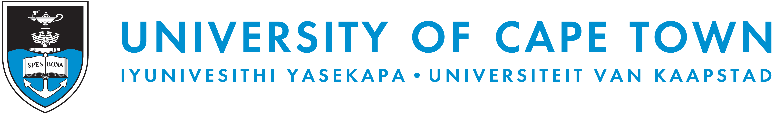
-------------------------------------------------------------------------------------------------- >>> cut here
For updates and further information please contact the student:_________________________
Email:________________________________
Cellphone number: _____________________________________
He/she will inform you about the progress on the digital story and secure your consent if requested.
Thank you for your participation and support of UCT Environmental and Geographical Science 3rd year students.

